The Effects of Garlic and Vitamin C on Human Blood Pressure

From: Youssef Ftouni
To: Todd Lichtenwalter
For: 8th Grade ACS Integrated Science
Date: April 19, 2007

Table Of Contents

Abstract………………………………………………………….. Page 2
Introduction……………………………………………………… Page 3
Literature Review………………………………………………... Page 6
Materials and Method.…………………………………………... Page 11
Results…………………………………………………………… Page 13
Discussion and Conclusion……....……………………………… Page 25
Acknowledgments…………….....………………………………. Page 28
Literature Cited……………………………………………….…. Page 29
Abstract

My study in this perticular eperiment was about how the two supplements, garlic, and vitamin C affect the blood pressure in humans, if taken over a period of 31 days. I wanted to see wether daily consumtion of these supplements, both independantly and dependantly, would actually regulate or sustain the blood pressure in humans with mild hypertension.
The first thing I did inorder to begin with my experiment was that I collected sixteen people with mild hypertension that would be glad to volunteer their time into this experiment. Then I bought the right amount of supplements, and I divided the 16 people into 4 groups of 4. The first group would only consume vitamin C, the second group would only consume garlic, the third group would consume both and the fourth group would be the control. They began taking the given supplements daily, and their blood pressure was taken using a sphygmomanometer every two days from the beginning of their experiment until the end of the 31st day.
In the end, my alternative hypothesis turned out to be correct. After the experimenting period was done, I gathered all of my results and put them into 4 tables with averages and graphed the averages. I had found out that in the vitamin C group, the blood pressure had regulated and dropped by 6% as an average. The garlic group’s average blood pressure had dropped by 7%. As for the vitamin C and garlic group, it had regulated and dropped by 9.5% as an average. The control group’s blood pressure stayed the same with no regulation of any kind. That means that vitamin C and garlic actually does affect and regulate the blood pressure in people with mild hypertension.
Introduction

Research Question:
Does garlic and vitamin C, both individually and in combination on mean systolic and diastolic blood pressure in human subject with mild hypertension, have any effects on blood pressure if measured with a sphygmomanometer?

H◦ (null hypothesis):
Avoidance and treatment of high blood pressure in humans are serious in preventing the occurrence of heart attacks and heart diseases. Many studies have shown that the intake of mineral deposits such as potassium, low intake of sodium and calcium are the basic focus of nutritional alteration. Nonetheless, antioxidants such as garlic and vitamin C would not affect or have little side affects on blood pressure.

HA (alternate hypothesis):
Avoidance and treatment of high blood pressure in humans are serious in preventing the occurrence of heart attacks and heart diseases. Many studies have shown that the intake of mineral deposits such as potassium, low intake of sodium and calcium are the basic focus of nutritional alteration. Nonetheless, antioxidants such as garlic and vitamin C may have a distinguishing side affect on blood pressure.

Independent Variable:
My independent variables are garlic tablets containing 1,250 mg of garlic per tablet and vitamin C tablets containing 500 mg of ascorbic acid in each tablet.

Dependant Variable:
My dependant variable is the impact of the different tablets taken on human blood pressure, which will be measured every 2 days for a period of 4 weeks using a sygmomanometer that measures blood pressure.

Control Variables:
In order to limit the influence of other factors on my study, the following variables will be controlled:

- The dosage of ascorbic acid consumed in vitamin C will be limited to 500 mg per day.
- The dosage of garlic consumed will also be inadequate to 1,250 mg of garlic per day.
- Tablets and supplements will only be consumed during lunch at about 12:00 pm every day.
- Patients have to be older than 18 years old.

Literature Review

Blood pressure affects several hundred million people in the world. Blood pressure is the force in the arteries when the heart beats (systolic pressure) and when the heart is at rest (diastolic pressure), that can cause many death threatening diseases. Several things are thought to be correlated with the high systolic and diastolic blood pressure in humans. Some examples include obesity or excessive eating, underlying conditions, genes, smoking, little exercise, and unknown reasons etc (Thompson 2006)… In this present paper, the role attachment plays in human blood pressure and how it changes to different intakes of substances. It is hypothesized that people who experience high stress conditions in their lives experience high blood pressure, and those who experience anxiety or depression have low blood pressure. My job was to see whether everyday foods that contain the supplements vitamin C and garlic, can decrease the problem of high blood pressure in humans.
In an article by “Kathleen Wright; Black Enterprise, 2001”, two categories were used to describe blood pressure, which were diastolic blood pressure and systolic blood pressure. Diastolic blood pressure was talked about as the measurement of force as the heart relaxes to allow the blood to flow into the heart, while systolic pressure was the force that blood applies on the artery walls as the heart contracts to pump out the blood. Diastolic pressure is usually the higher number and first number, while systolic is the lower and secondary number recorded while measuring blood pressure. Blood pressure is measured in millimeters of mercury (mm Hg). High blood pressure (or hypertension) was defined in an adult as a blood pressure greater than or equal to 140 mm Hg systolic pressure or greater than or equal to 90 mm Hg diastolic pressure. For example, excellent blood pressure would be less than 120/80 mm Hg (systolic/diastolic). Blood pressure is now categorized as low, optimal, normal, high normal, and hypertensive. The hypertensive category is furthermore divided, according to severity. High blood pressure is also called hypertension. Hypertension is the force of blood pushing against the walls of arteries as it flows through them. As blood passes through arteries, it pushes agianst inside the arterie’s walls. The more there is pressure in the blood and on the artery walls, the higher the blood pressure. Different sizes of arteries also affect blood pressure. Whenever muscles in the blood vessels relax, blood pressure decreases. When Blood pressure is at its pivotal point, the heart beats to push blood out into the arteries. When the heart relaxes to fill with blood again, the pressure is at its lowest point. The American Heart Association states that blood pressure over 140 mm Hg, and over 90 mm Hg is high for adults. Hypertension is a major health problem, mostly because it has little or probably no symptoms. Numerous amounts of people have hypertension without knowing it. In the United States, some 50 million inhabitants from the age of six and above have high blood pressure (Mirken & and Pascual 2006). It is also said that hypertension may be more common in men than women and in people over the age of 65, that in teenagers and younger people. More than half of all Americans over the age of 65 have hypertension. Hypertension can be one of the most deadly silent killers known to humans.
In a research article by Carol.A Turkington, hypotension was described as a medical term for low blood pressure. It was also explained that hypotension occurs when little blood reaches the brain and can cause fainting or dizziness. The research article explained that the most common hypotension found in humans is called postural hypotension, which is when a person sits up or stands quickly leaving little blood reach the brain. That is basicly because when a person stands up quickly, the blood that is being pumped into the brain is pushed back, and the brain would have little blood pumped inside of it. That causes a feeling of diziness in a person and can cause a black out in the eyes, and sometimes feinting.
Vitamin C and garlic are supplements can benefit the body in many different ways. One of which is that they can change the blood pressure in humans with mild hypertension. Many scientists had turned out to have already tested this, and had resulted in similar outcomes. Researchers at Brown University School of Medicine in Rhode Island had already tested garlic on many human subjects to observe the change in blood pressure. Other researchers at the Medical College of Georgia in Augusta had also tested vitamin C on human specimens to see whether it would lower their blood pressure over a period of time. Another professor in the Oregon State University had also experimented with vitamin C to examine whether blood pressure decreases after consuming an amount of vitamin C in a daily basis.
The researchers at Brown University School of Medicine had reported that supplementation with garlic extracts would lower cholesterol levels and blood pressure in men with high blood pressure. They had chosen 41 men aged 32 to 68 and started the study. The men were given 800 mg of garlic extract supplements daily for a period of six months. The garlic had resulted in a decrease of 5.5 percent of diastolic and systolic blood pressure in the men, in average. As for the researchers in the Medical College of Georgia, they had tested different amounts of supplements of vitamin C on 168 human subjects in which 56 where taking supplements of ascorbic acid. After the end of their experimenting period, they had found out that the blood pressure in all subjects taking the supplements had decreased dramatically with a decrease of 5 mm Hg, in average. As for professor David Stauth in the Oregon State University, he had experimented with a dosage of 500 mg of vitamin C on 45 human volunteers daily. His hypertensive patients were chosen based on age, and gender. He established out that exactly 500 mg of vitamin C daily on a long term basis could yield more safe blood pressure decline than those that are found in prescription drugs. His results more clearly stated that all in all, 500 mg of vitamin C daily would reduce the systolic and diastolic blood pressure in individuals by 9 percent (10 mm Hg) in a mean average. He also concluded that vitamin C in general could save lives if consumed daily, since high blood pressure is becoming one of the biggest problems that humans are facing every day.
Before I ever started or thought about my research, I barely knew anything about human blood pressure and how it works. I didn’t know what diastolic blood pressure meant, and I didn’t know what systolic pressure meant, not to mention how blood pressure occurs in the body in the first place. I knew little about measuring blood pressure, about how you classify blood pressure, and about the instruments you use to measure blood pressure. The most important thing that I learned was the way Ace Inhibitor chemicals in the body cause the blood vessels to contract, which causes high blood pressure. I also learned that the garlic supplement and vitamin C have special chemicals that react with this Ace Inhibitor, causing less production of this chemical, causing less blood pressure and more relaxed blood vessels. This really gave me a visualization of how blood pressure works, and it made it easier for me to understand other information about related to blood pressure.
This background information undoubtedly gave me an idea of what to do with my experiment. I had decided to do the same thing the researchers had done, which was to test the garlic and vitamin C on several people, and to see at the end whether the blood pressure decreased dramatically or not at all in different groups, by measuring their blood pressure many times whilst the experiment is taking place. At first, I was hesitating about how to do this experiment. I didn’t know how to organize it, or who to get for my experiment. After going through some of the experiments already done, I was given an idea of what to do exactly, and how to state my results. I learned that I should choose about 4 people in each of my 4 groups, to get more accurate averages. I also learned that I should clearly and strictly state the control variables to each group, so that other factors may not seriously interfere with my experiment. In the end, this whole experience of learning about the blood pressure in human bodies was really interesting, because it gave me an I idea of what I might continue doing when I grow up. I was never pushed to the limit of doing such experiments and reports, and to learn such information would certainly benefit me in the future. It would benefit me by increasing my knowledge about the human body, and it would make it easier for me to learn about more complex systems that form our human body.

Materials and Method

This study was conducted on 16 chosen patients with mild hypertension who were willing to volunteer their time for one month to participate in my study. Four volunteers had been given a 30-day supply of garlic tablets containing 1,250 mg of garlic per tablet and instructions for taking the supplements daily. Another group of four volunteers had been given a supply of vitamin C tablets containing 500 mg of ascorbic acid in each tablet and instructions for taking the supplements daily. A third group of four volunteers was also given a 30-day supply of garlic and vitamin C tablets (1,250 mg and 500 mg each) and instructions for taking both supplements daily. I also chose 4 other patients to be measured as a control group. A physician had confirmed that the volunteers are not allergic to the supplements. Once the volunteers began taking the supplements, each volunteer had his or her blood pressure measured every two days for a period of four consecutive weeks, while taking the supplements, using a digital blood pressure machine for systolic and diastolic blood pressure (mmHg) monitoring. The average resting systolic and diastolic blood pressure had been measured for each person and recorded on a computer graph using Microsoft Excel and Word document, to show the relationship and correlation in the change of blood pressure.

Figure 1. Experimental Design

Control Group Experimental Group 1
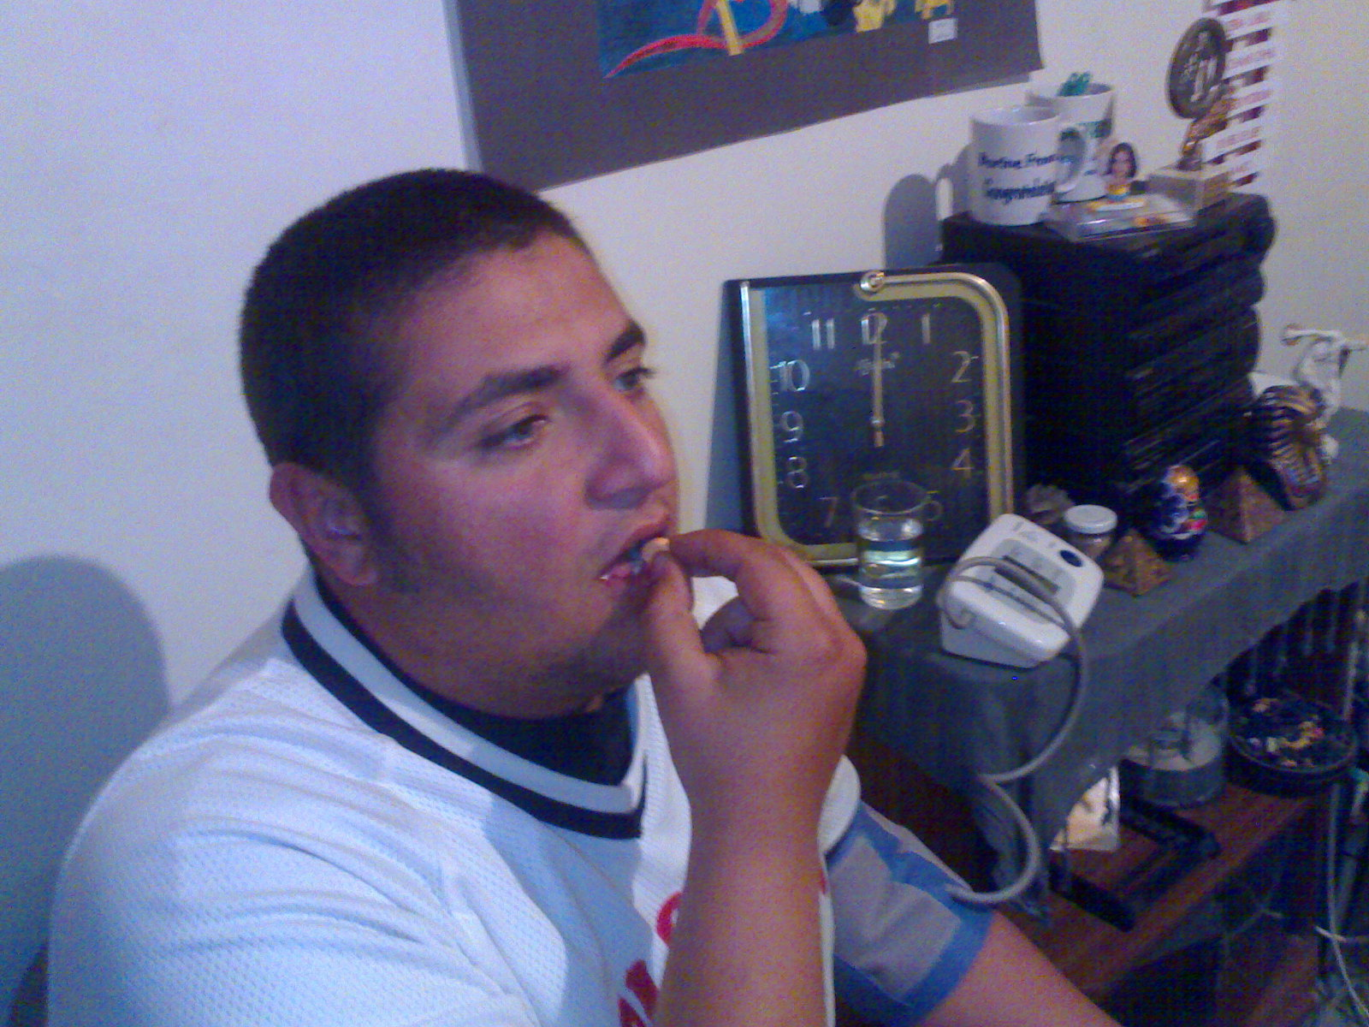
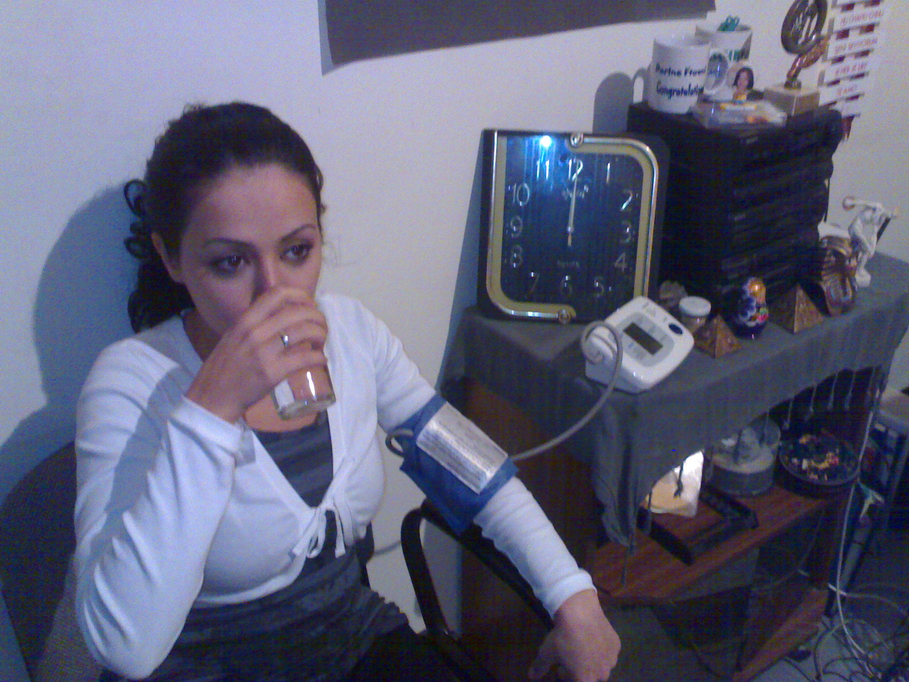

Adult drinking water and not eating Adult consuming a vitamin C pill
any vitamin C or garlic. with 500 mg of ascorbic acid.
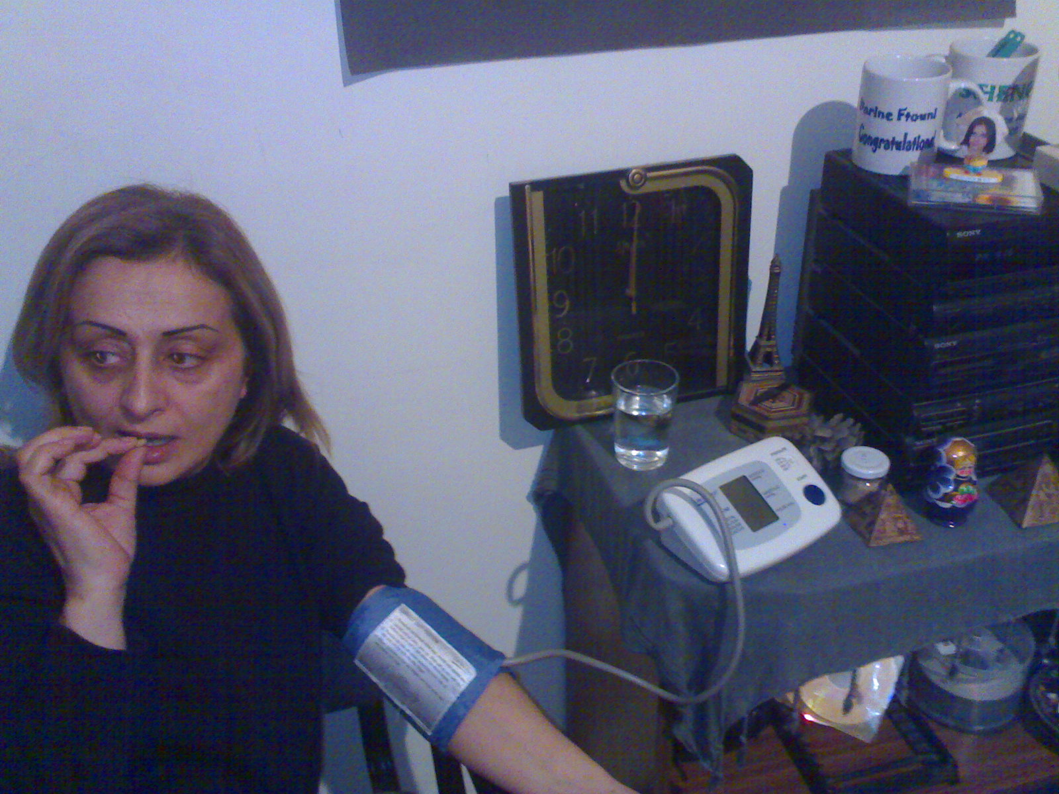
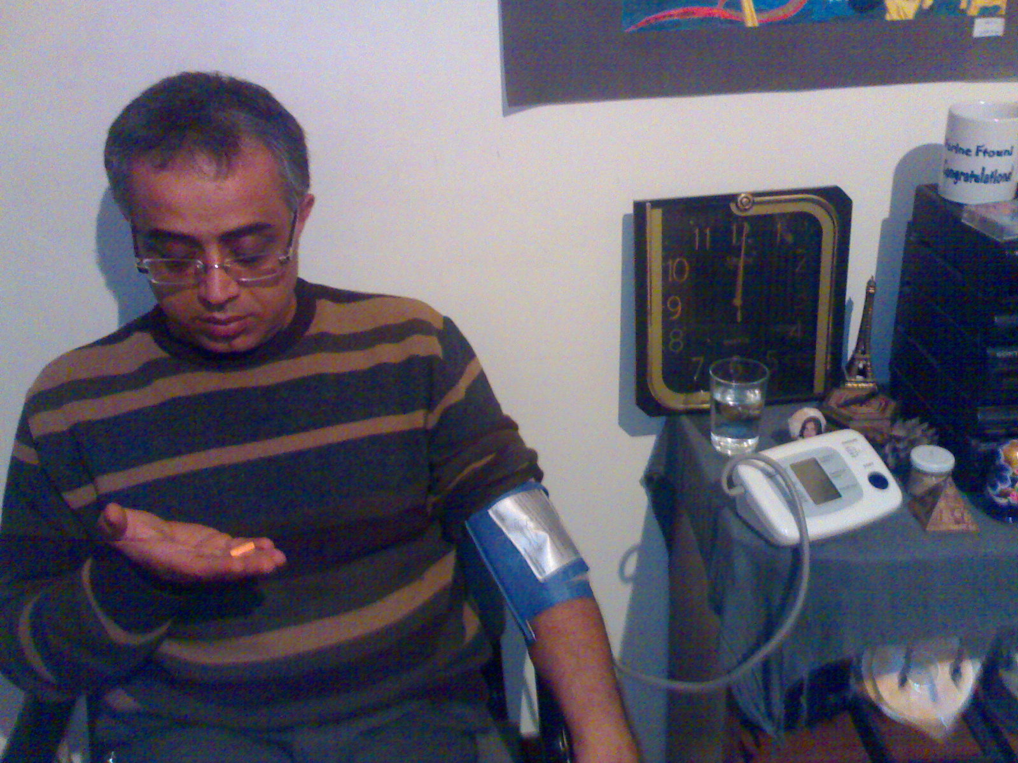
Clock to measure blood at exact time. Sphygmomanometer Clock at 12:00 pm

Experimental Group 2 Experimental Group 3

Clock

Adult consuming 1’250 mg of garlic tablet. Adult taking a pill of 500 mg of ascorbic

acid (vitamin C) and 1’250 mg of garlic.
A sphygmomanometer that measures

the blood pressure of the patient. A sphygmomanometer on the left hand
Results

Table 1.1 The systolic blood pressure results for the garlic group
Name | Age (years) | Blood Pressure (systolic mmHg)
Dina Hamade | 22 | 120 | 125 | 120 | 120 | 120 | 110 | 110 | 115 | 115 | 110 | 115 | 110 | 110 | 110 | 110 | 110
Ahmad Hamade | 50 | 130 | 125 | 130 | 130 | 130 | 130 | 130 | 130 | 125 | 125 | 125 | 120 | 120 | 120 | 120 | 120
Mohammad Ftouni | 55 | 120 | 125 | 125 | 125 | 125 | 130 | 125 | 120 | 120 | 125 | 125 | 125 | 120 | 120 | 120 | 120
Khadije Moussa | 45 | 130 | 120 | 125 | 125 | 125 | 120 | 130 | 120 | 125 | 130 | 125 | 125 | 125 | 125 | 120 | 120
Day | ---- | 1 | 3 | 5 | 7 | 9 | 11 | 13 | 15 | 17 | 19 | 21 | 23 | 25 | 27 | 29 | 31
Mean |  | 125 | 123.75 | 125 | 125 | 125 | 122.5 | 123.75 | 121.25 | 121.25 | 122.5 | 122.5 | 120 | 118.75 | 118.75 | 117.5 | 117.5
Median |  | 125 | 125 | 125 | 125 | 125 | 125 | 127.5 | 120 | 122.5 | 125 | 125 | 122.5 | 120 | 120 | 120 | 120
Range |  | 10 | 5 | 10 | 10 | 10 | 20 | 20 | 15 | 10 | 20 | 10 | 15 | 15 | 15 | 10 | 10
Variance |  | 33.3333 | 6.25 | 16.6667 | 16.6667 | 16.6667 | 91.6667 | 89.5833 | 39.5833 | 22.9167 | 75 | 25 | 50 | 39.5833 | 39.5833 | 25 | 25
SD |  | 5.7735 | 2.5 | 4.08248 | 4.08248 | 4.08248 | 9.57427 | 9.46485 | 6.29153 | 4.78714 | 8.66025 | 5 | 7.07107 | 6.29153 | 6.29153 | 5 | 5
SE |  | 2.88675 | 1.25 | 2.04124 | 2.04124 | 2.04124 | 4.78714 | 4.73242 | 3.14576 | 2.39357 | 4.33013 | 2.5 | 3.53553 | 3.14576 | 3.14576 | 2.5 | 2.5
95%ci (Excel) |  | 5.65793 | 2.44995 | 4.00076 | 4.00076 | 4.00076 | 9.38261 | 9.27537 | 6.16558 | 4.6913 | 8.48689 | 4.89991 | 6.92951 | 6.16558 | 6.16558 | 4.89991 | 4.89991

In the garlic group’s systolic blood pressure table, we can see that all patients had a noticeable decrease in their blood pressure in the end of the experiment, compared to the beginning of the experiment.

Table 1.2 The diastolic blood pressure results for the garlic group
Name | Age (years) | Blood Pressure (diastolic mmHg)
Dina Hamade | 22 | 70 | 70 | 70 | 70 | 70 | 65 | 60 | 65 | 65 | 70 | 75 | 70 | 65 | 65 | 65 | 65
Ahmad Hamade | 50 | 70 | 70 | 75 | 80 | 75 | 80 | 75 | 70 | 70 | 70 | 75 | 70 | 70 | 70 | 70 | 70
Mohammad Ftouni | 55 | 80 | 80 | 80 | 75 | 75 | 75 | 70 | 70 | 70 | 70 | 70 | 70 | 70 | 70 | 70 | 70
Khadije Moussa | 45 | 80 | 75 | 75 | 75 | 75 | 75 | 70 | 70 | 75 | 75 | 75 | 75 | 75 | 75 | 70 | 70
Day | ---- | 1 | 3 | 5 | 7 | 9 | 11 | 13 | 15 | 17 | 19 | 21 | 23 | 25 | 27 | 29 | 31
Mean |  | 75 | 73.75 | 75 | 75 | 73.75 | 73.75 | 68.75 | 68.75 | 70 | 71.25 | 73.75 | 71.25 | 70 | 70 | 68.75 | 68.75
Median |  | 75 | 72.5 | 75 | 75 | 75 | 75 | 70 | 70 | 70 | 70 | 75 | 70 | 70 | 70 | 70 | 70
Range |  | 10 | 10 | 10 | 10 | 5 | 15 | 15 | 5 | 10 | 5 | 5 | 5 | 10 | 10 | 5 | 5
Variance |  | 33.3333 | 22.9167 | 16.6667 | 16.6667 | 6.25 | 39.5833 | 39.5833 | 6.25 | 16.6667 | 6.25 | 6.25 | 6.25 | 16.6667 | 16.6667 | 6.25 | 6.25
SD |  | 5.7735 | 4.78714 | 4.08248 | 4.08248 | 2.5 | 6.29153 | 6.29153 | 2.5 | 4.08248 | 2.5 | 2.5 | 2.5 | 4.08248 | 4.08248 | 2.5 | 2.5
SE |  | 2.88675 | 2.39357 | 2.04124 | 2.04124 | 1.25 | 3.14576 | 3.14576 | 1.25 | 2.04124 | 1.25 | 1.25 | 1.25 | 2.04124 | 2.04124 | 1.25 | 1.25
95%ci (Excel) |  | 5.65793 | 4.6913 | 4.00076 | 4.00076 | 2.44995 | 6.16558 | 6.16558 | 2.44995 | 4.00076 | 2.44995 | 2.44995 | 2.44995 | 4.00076 | 4.00076 | 2.44995 | 2.44995

In the garlic group’s systolic blood pressure table, we can also see that there was a noticeable drop in the blood pressure at the end of the experiment.

Table 1.3 The systolic blood pressure results for the vitamin C group
Name | Age (years) | Blood Pressure (systolic mmHg)
Isra Hamade | 75 | 140 | 140 | 140 | 140 | 140 | 140 | 140 | 135 | 140 | 135 | 140 | 135 | 135 | 130 | 130 | 130
Lina Atwe | 23 | 130 | 130 | 130 | 125 | 130 | 130 | 130 | 130 | 130 | 125 | 130 | 130 | 125 | 125 | 125 | 125
Anaya Hamade | 47 | 125 | 130 | 130 | 130 | 130 | 125 | 125 | 125 | 130 | 125 | 125 | 125 | 125 | 120 | 120 | 120
Farouk Atwe | 60 | 110 | 110 | 120 | 115 | 115 | 110 | 110 | 110 | 110 | 110 | 110 | 110 | 110 | 110 | 110 | 110
Day | ---- | 1 | 3 | 5 | 7 | 9 | 11 | 13 | 15 | 17 | 19 | 21 | 23 | 25 | 27 | 29 | 31
Mean |  | 126.25 | 127.5 | 130 | 127.5 | 128.75 | 126.25 | 126.25 | 125 | 127.5 | 123.75 | 126.25 | 125 | 123.75 | 121.25 | 121.25 | 121.25
Median |  | 127.5 | 130 | 130 | 127.5 | 130 | 127.5 | 127.5 | 127.5 | 130 | 125 | 127.5 | 127.5 | 125 | 122.5 | 122.5 | 122.5
Range |  | 30 | 30 | 20 | 25 | 25 | 30 | 30 | 25 | 30 | 25 | 30 | 25 | 25 | 20 | 20 | 20
Variance |  | 156.25 | 158.333 | 66.6667 | 108.333 | 106.25 | 156.25 | 156.25 | 116.667 | 158.333 | 106.25 | 156.25 | 116.667 | 106.25 | 72.9167 | 72.9167 | 72.9167
SD |  | 12.5 | 12.5831 | 8.16497 | 10.4083 | 10.3078 | 12.5 | 12.5 | 10.8012 | 12.5831 | 10.3078 | 12.5 | 10.8012 | 10.3078 | 8.53913 | 8.53913 | 8.53913
SE |  | 6.25 | 6.29153 | 4.08248 | 5.20416 | 5.15388 | 6.25 | 6.25 | 5.40062 | 6.29153 | 5.15388 | 6.25 | 5.40062 | 5.15388 | 4.26956 | 4.26956 | 4.26956
95%ci (Excel) |  | 12.2498 | 12.3312 | 8.00151 | 10.2 | 10.1014 | 12.2498 | 12.2498 | 10.585 | 12.3312 | 10.1014 | 12.2498 | 10.585 | 10.1014 | 8.36818 | 8.36818 | 8.36818

In the vitamin C group’s systolic blood pressure table, we can also acknowledge that the blood pressure of this group dropped, after the consumption of 500 mg of vitamin C over a 31 day period.

Table 1.4 The diastolic blood pressure results for the vitamin C group
Name | Age (years) | Blood Pressure (diastolic mmHg)
Isra Hamade | 75 | 70 | 80 | 70 | 70 | 80 | 80 | 70 | 70 | 70 | 80 | 85 | 75 | 75 | 70 | 70 | 70
Lina Atwe | 23 | 75 | 75 | 70 | 70 | 75 | 75 | 75 | 75 | 75 | 70 | 75 | 75 | 70 | 70 | 70 | 70
Anaya Hamade | 47 | 70 | 70 | 70 | 70 | 65 | 70 | 60 | 60 | 60 | 60 | 60 | 60 | 60 | 60 | 60 | 60
Farouk Atwe | 60 | 80 | 75 | 75 | 75 | 75 | 75 | 75 | 75 | 70 | 70 | 70 | 70 | 70 | 70 | 70 | 70
Day | ---- | 1 | 3 | 5 | 7 | 9 | 11 | 13 | 15 | 17 | 19 | 21 | 23 | 25 | 27 | 29 | 31
Mean |  | 73.75 | 75 | 71.25 | 71.25 | 73.75 | 75 | 70 | 70 | 68.75 | 70 | 72.5 | 70 | 68.75 | 67.5 | 67.5 | 67.5
Median |  | 72.5 | 75 | 70 | 70 | 75 | 75 | 72.5 | 72.5 | 70 | 70 | 72.5 | 72.5 | 70 | 70 | 70 | 70
Range |  | 10 | 10 | 5 | 5 | 15 | 10 | 15 | 15 | 15 | 20 | 25 | 15 | 15 | 10 | 10 | 10
Variance |  | 22.9167 | 16.6667 | 6.25 | 6.25 | 39.5833 | 16.6667 | 50 | 50 | 39.5833 | 66.6667 | 108.333 | 50 | 39.5833 | 25 | 25 | 25
SD |  | 4.78714 | 4.08248 | 2.5 | 2.5 | 6.29153 | 4.08248 | 7.07107 | 7.07107 | 6.29153 | 8.16497 | 10.4083 | 7.07107 | 6.29153 | 5 | 5 | 5
SE |  | 2.39357 | 2.04124 | 1.25 | 1.25 | 3.14576 | 2.04124 | 3.53553 | 3.53553 | 3.14576 | 4.08248 | 5.20416 | 3.53553 | 3.14576 | 2.5 | 2.5 | 2.5
95%ci (Excel) |  | 4.6913 | 4.00076 | 2.44995 | 2.44995 | 6.16558 | 4.00076 | 6.92951 | 6.92951 | 6.16558 | 8.00151 | 10.2 | 6.92951 | 6.16558 | 4.89991 | 4.89991 | 4.89991

The vitamin C group’s diastolic blood pressure results show that the diastolic blood pressure for this group had dropped after the consumption of vitamin C.

Table 1.5 The systolic blood pressure results for the vitamin C and garlic group
Name | Age (years) | Blood Pressure (systolic mmHg)
Houssain Ftouni | 22 | 130 | 130 | 130 | 130 | 125 | 125 | 125 | 130 | 125 | 125 | 120 | 120 | 120 | 120 | 120 | 120
Ismail Ftouni | 25 | 120 | 120 | 120 | 120 | 125 | 125 | 120 | 120 | 115 | 115 | 115 | 115 | 115 | 115 | 115 | 115
Ilham Ftouni | 58 | 120 | 120 | 120 | 120 | 110 | 110 | 110 | 110 | 110 | 110 | 110 | 110 | 110 | 110 | 110 | 110
Micheal Ftouni | 19 | 125 | 125 | 130 | 130 | 120 | 120 | 120 | 120 | 120 | 120 | 120 | 120 | 125 | 110 | 110 | 110
Day | ---- | 1 | 3 | 5 | 7 | 9 | 11 | 13 | 15 | 17 | 19 | 21 | 23 | 25 | 27 | 29 | 31
Mean |  | 123.75 | 123.75 | 125 | 125 | 120 | 120 | 118.75 | 120 | 117.5 | 117.5 | 116.25 | 116.25 | 117.5 | 113.75 | 113.75 | 113.75
Median |  | 122.5 | 122.5 | 125 | 125 | 122.5 | 122.5 | 120 | 120 | 117.5 | 117.5 | 117.5 | 117.5 | 117.5 | 112.5 | 112.5 | 112.5
Range |  | 10 | 10 | 10 | 10 | 15 | 15 | 15 | 20 | 15 | 15 | 10 | 10 | 15 | 10 | 10 | 10
Variance |  | 22.9167 | 22.9167 | 33.3333 | 33.3333 | 50 | 50 | 39.5833 | 66.6667 | 41.6667 | 41.6667 | 22.9167 | 22.9167 | 41.6667 | 22.9167 | 22.9167 | 22.9167
SD |  | 4.78714 | 4.78714 | 5.7735 | 5.7735 | 7.07107 | 7.07107 | 6.29153 | 8.16497 | 6.45497 | 6.45497 | 4.78714 | 4.78714 | 6.45497 | 4.78714 | 4.78714 | 4.78714
SE |  | 2.39357 | 2.39357 | 2.88675 | 2.88675 | 3.53553 | 3.53553 | 3.14576 | 4.08248 | 3.22749 | 3.22749 | 2.39357 | 2.39357 | 3.22749 | 2.39357 | 2.39357 | 2.39357
95%ci (Excel) |  | 4.6913 | 4.6913 | 5.65793 | 5.65793 | 6.92951 | 6.92951 | 6.16558 | 8.00151 | 6.32575 | 6.32575 | 4.6913 | 4.6913 | 6.32575 | 4.6913 | 4.6913 | 4.6913

The vitamin C and garlic group’s systolic results table also shows that the blood pressure of this group had dropped after a 31 day period.

Table 1.6 The diastolic blood pressure results for the vitamin C and garlic group
Name | Age (years) | Blood Pressure (diastolic mmHg)
Houssain Ftouni | 22 | 80 | 80 | 75 | 75 | 75 | 70 | 70 | 70 | 70 | 70 | 70 | 70 | 70 | 70 | 70 | 70
Ismail Ftouni | 25 | 75 | 75 | 70 | 70 | 75 | 75 | 75 | 75 | 70 | 70 | 70 | 65 | 65 | 65 | 65 | 65
Ilham Ftouni | 58 | 65 | 60 | 70 | 70 | 65 | 65 | 65 | 60 | 60 | 60 | 60 | 60 | 60 | 60 | 60 | 60
Micheal Ftouni | 19 | 75 | 75 | 70 | 80 | 80 | 80 | 80 | 70 | 70 | 70 | 70 | 70 | 75 | 70 | 65 | 65
Day | ---- | 1 | 3 | 5 | 7 | 9 | 11 | 13 | 15 | 17 | 19 | 21 | 23 | 25 | 27 | 29 | 31
Mean |  | 73.75 | 72.5 | 71.25 | 73.75 | 73.75 | 72.5 | 72.5 | 68.75 | 67.5 | 67.5 | 67.5 | 66.25 | 67.5 | 66.25 | 65 | 65
Median |  | 75 | 75 | 70 | 72.5 | 75 | 72.5 | 72.5 | 70 | 70 | 70 | 70 | 67.5 | 67.5 | 67.5 | 65 | 65
Range |  | 15 | 20 | 5 | 10 | 15 | 15 | 15 | 15 | 10 | 10 | 10 | 10 | 15 | 10 | 10 | 10
Variance |  | 39.5833 | 75 | 6.25 | 22.9167 | 39.5833 | 41.6667 | 41.6667 | 39.5833 | 25 | 25 | 25 | 22.9167 | 41.6667 | 22.9167 | 16.6667 | 16.6667
SD |  | 6.29153 | 8.66025 | 2.5 | 4.78714 | 6.29153 | 6.45497 | 6.45497 | 6.29153 | 5 | 5 | 5 | 4.78714 | 6.45497 | 4.78714 | 4.08248 | 4.08248
SE |  | 3.14576 | 4.33013 | 1.25 | 2.39357 | 3.14576 | 3.22749 | 3.22749 | 3.14576 | 2.5 | 2.5 | 2.5 | 2.39357 | 3.22749 | 2.39357 | 2.04124 | 2.04124
95%ci (Excel) |  | 6.16558 | 8.48689 | 2.44995 | 4.6913 | 6.16558 | 6.32575 | 6.32575 | 6.16558 | 4.89991 | 4.89991 | 4.89991 | 4.6913 | 6.32575 | 4.6913 | 4.00076 | 4.00076

The vitamin C and garlic group’s diastolic blood pressure table results also show the decrease of blood pressure after during the 31 day period of testing.

Table 1.7 The systolic blood pressure results for the control group
Name | Age (years) | Blood Pressure (systolic mmHg)
Iman Hamade | 40 | 110 | 110 | 100 | 100 | 100 | 100 | 100 | 110 | 110 | 110 | 110 | 110 | 110 | 110 | 110 | 110
Sawsan Hamade | 45 | 100 | 110 | 110 | 100 | 100 | 100 | 100 | 100 | 100 | 100 | 110 | 110 | 110 | 110 | 110 | 110
Farah Hamade | 23 | 120 | 120 | 120 | 120 | 120 | 120 | 120 | 120 | 125 | 125 | 120 | 120 | 120 | 120 | 120 | 120
Hassan Ftouni | 57 | 140 | 135 | 140 | 140 | 140 | 135 | 135 | 135 | 135 | 140 | 135 | 130 | 130 | 135 | 135 | 135
Day | ---- | 1 | 3 | 5 | 7 | 9 | 11 | 13 | 15 | 17 | 19 | 21 | 23 | 25 | 27 | 29 | 31
Mean |  | 117.5 | 118.75 | 117.5 | 115 | 115 | 113.75 | 113.75 | 116.25 | 117.5 | 118.75 | 118.75 | 117.5 | 117.5 | 118.75 | 118.75 | 118.75
Median |  | 115 | 115 | 115 | 110 | 110 | 110 | 110 | 115 | 117.5 | 117.5 | 115 | 115 | 115 | 115 | 115 | 115
Range |  | 40 | 25 | 40 | 40 | 40 | 35 | 35 | 35 | 35 | 40 | 25 | 20 | 20 | 25 | 25 | 25
Variance |  | 291.667 | 139.583 | 291.667 | 366.667 | 366.667 | 289.583 | 289.583 | 222.917 | 241.667 | 306.25 | 139.583 | 91.6667 | 91.6667 | 139.583 | 139.583 | 139.583
SD |  | 17.0783 | 11.8145 | 17.0783 | 19.1485 | 19.1485 | 17.0171 | 17.0171 | 14.9304 | 15.5456 | 17.5 | 11.8145 | 9.57427 | 9.57427 | 11.8145 | 11.8145 | 11.8145
SE |  | 8.53913 | 5.90727 | 8.53913 | 9.57427 | 9.57427 | 8.50857 | 8.50857 | 7.4652 | 7.77282 | 8.75 | 5.90727 | 4.78714 | 4.78714 | 5.90727 | 5.90727 | 5.90727
95%ci (Excel) |  | 16.7364 | 11.578 | 16.7364 | 18.7652 | 18.7652 | 16.6765 | 16.6765 | 14.6315 | 15.2344 | 17.1497 | 11.578 | 9.38261 | 9.38261 | 11.578 | 11.578 | 11.578

The control group’s systolic blood pressure results table shows that the systolic blood pressure of this group has not decreased or regulated over the 31 day testing period.

Table 1.8 The diastolic blood pressure results for the control group
Name | Age (years) | Blood Pressure (diastolic mmHg)
Iman Hamade | 40 | 60 | 60 | 60 | 60 | 60 | 60 | 60 | 60 | 60 | 60 | 60 | 60 | 60 | 60 | 60 | 60
Sawsan Hamade | 45 | 60 | 65 | 60 | 60 | 60 | 60 | 60 | 60 | 60 | 60 | 60 | 60 | 60 | 60 | 60 | 60
Farah Hamade | 23 | 70 | 70 | 70 | 70 | 70 | 70 | 70 | 70 | 75 | 80 | 70 | 65 | 70 | 70 | 70 | 70
Hassan Ftouni | 57 | 85 | 80 | 85 | 90 | 90 | 85 | 85 | 85 | 85 | 85 | 80 | 80 | 80 | 85 | 85 | 85
Day | ---- | 1 | 3 | 5 | 7 | 9 | 11 | 13 | 15 | 17 | 19 | 21 | 23 | 25 | 27 | 29 | 31
Mean |  | 68.75 | 68.75 | 68.75 | 70 | 70 | 68.75 | 68.75 | 68.75 | 70 | 71.25 | 67.5 | 66.25 | 67.5 | 68.75 | 68.75 | 68.75
Median |  | 65 | 67.5 | 65 | 65 | 65 | 65 | 65 | 65 | 67.5 | 70 | 65 | 62.5 | 65 | 65 | 65 | 65
Range |  | 25 | 20 | 25 | 30 | 30 | 25 | 25 | 25 | 25 | 25 | 20 | 20 | 20 | 25 | 25 | 25
Variance |  | 139.583 | 72.9167 | 139.583 | 200 | 200 | 139.583 | 139.583 | 139.583 | 150 | 172.917 | 91.6667 | 89.5833 | 91.6667 | 139.583 | 139.583 | 139.583
SD |  | 11.8145 | 8.53913 | 11.8145 | 14.1421 | 14.1421 | 11.8145 | 11.8145 | 11.8145 | 12.2474 | 13.1498 | 9.57427 | 9.46485 | 9.57427 | 11.8145 | 11.8145 | 11.8145
SE |  | 5.90727 | 4.26956 | 5.90727 | 7.07107 | 7.07107 | 5.90727 | 5.90727 | 5.90727 | 6.12372 | 6.57489 | 4.78714 | 4.73242 | 4.78714 | 5.90727 | 5.90727 | 5.90727
95%ci (Excel) |  | 11.578 | 8.36818 | 11.578 | 13.859 | 13.859 | 11.578 | 11.578 | 11.578 | 12.0023 | 12.8865 | 9.38261 | 9.27537 | 9.38261 | 11.578 | 11.578 | 11.578

The control group’s diastolic blood pressure results show that the diastolic blood pressure results for this group have not showed any positive change or regulation, after the end of the 31 day testing period.

Figure 1.1 shows the variation of the systolic and diastolic blood pressure as a function of time, and it also shows the decreasing trends of blood pressure for the garlic group.

Figure 1.2 shows the 31 day relationship and decreasing trends of the systolic and diastolic blood pressure results for the vitamin C group.

Figure 1.3 illustrates the decreasing trends of the systolic and diastolic blood pressure results for the vitamin C and garlic group.

Figure 1.4 demonstrates the neutral trends of the 31 day systolic and diastolic blood pressure results for the control group.

Discussion and Conclusion

When I had found out about this experiment, I had thought to myself that vitamin C and garlic would probably affect blood pressure, since all kinds of natural and healthy supplements such as these would benefit the body in some way. The only thing I didn’t know was how much that would be, and at what rate. I had found out that the average blood pressure of the garlic group had dropped from 125 systolic mmHg to 117.5 systolic mmHg and from 75 diastolic mmHg to 68.75 diastolic mmHg in just 31 days. In other words, the systolic blood pressure had dropped by 6% and the diastolic by 8%. This means that the consumption of garlic independently over a long period of time causes fast and adequate change in the blood pressure in a human body, if consumed at a daily basis. As for the vitamin C group, the change was also adequate buy not as much as the garlic. At the beginning of the experiment, the average blood pressure results for the vitamin C group were 126.5 systolic mmHg over 73.75 diastolic mmHg. At the end of the experiment, the average blood pressure results had dropped by 4 % systolic and 8 % diastolic. Until now, the garlic group had done better in systolic decrease in blood pressure and equal change in diastolic blood pressure if compared to the vitamin C group. The vitamin C and garlic group had 123.75 systolic mmHg over 73.75 diastolic mmHg at the start of the experiment, and ended the experiment with a systolic decrease of 8% and a diastolic decrease of 11%. This means that the combination of the two supplements created a faster and more sufficient regulation in the diastolic blood pressure if compared to the vitamin C group, and to the garlic group, and an equal decrease in systolic blood pressure. As for the control group, their average blood pressure results were 117.5 systolic mmHg over 68.75 diastolic mmHg on the first day of measuring and ended up with an increase of 1% systolic, while the diastolic blood pressure remained constant with no change. This means that the control group had no positive change or regulation in the blood pressure, during the whole 31 day experimental period. As a conclusion, the vitamin C supplement independently had the least effect on the blood pressure with a 6% change. The garlic supplement had a better decrease of 7%, while the combination of the two supplements produced the best regulation, with a decrease of 9.5 % as an average. With all of that said, I can finally conclude and contradict the fact that my null hypothesis was totally incorrect. Vitamin C and garlic had a clear, sufficient regulation and change in all 3 groups which were consuming these supplements, which means that my null hypothesis is false.
Improving in an experiment has endless possibilities, for a person can never perfectly accomplish an experiment without having something to improve or an error that could have been avoided. For my experiment, I could have done some stuff to improve slightly. One of which is that I could have strictly tightened the law of not consuming any other foods that might decrease the blood pressure more, or increase it by any chance. I could have used more people in each group, to have more accurate results, or I could have tested longer. Having more people in each group would give me better averages, because some people may have not been affected by some factors that others might have been affected from.
In my opinion, future experiments could be made leading from these findings. Since vitamin C and garlic are practically everyday elements in the food that we eat, we can acknowledge that other food elements, such as vinegar or vitamin A may also affect the body in some way that has not been tested yet. Never-ending possibilities in testing the positive or negative outcomes in foods become open, when we know that simple and everyday foods supplements such as vitamin C and garlic can actually save a life if consumed daily.
All in all, the results in my experiment totally support my alternate hypothesis, and I completely agree with that hypothesis. We have been given food and life on this Earth, and this food surely needs to benefit the body in some way or another.

Acknowledgments

I would like to thank all of the 16 patients who had volunteered their time in my experiment daily. I would also like to thank my mother who helped me in getting most of the supplements and sphygmomanometers. I would mostly like to thank Mr. Todd Lichtenwalter who had made all of this possible, and who had challenged me in ways I never thought I could be challenged in.

Literature Cited

Mirken, Bruce & Pascual, Psyche. “Women and High Blood Pressure.” AHealthyMe. 29 Dec. 2006. Consumer Health Interactive. 26 Jan. 2007 <http://www.ahealthyme.com/topic/bpwomen>.

Turkington, Carol. “Hypotension.” Find Articles. Gale Encyclopedia of Medicine.
26 Jan. 2007
<http://www.findarticles.com/p/articles/mi_g2601/is_0007/ai_2601000723>.

Stauth, David. “Vitamin C can reduce high blood pressure, study finds.” OSU News & Communication Services. Dec 17. 1999. Feb 10. 2007
<http://oregonstate.edu/dept/ncs/newsarch/1999/Dec99/level.htm>.

Thompson, Dennis. “Blood Pressure Woes Start Earlier Than You Think.” Keep Media. 23 Jul. 2006. ScoutNews, LLC. 25 Jan. 2007 <http://www.keepmedia.com/pubs/HealthDay/2006/06/23/1656132?extID=10037&oliID=229>.

“Hypertension and Diabetes.” The AGC Foundation For Health In Aging. 26 Jan, 2007 <http://www.healthinaging.org/public_education/diabetes/hypertension_diabetes.php>.

Moran. John P. “Prevention of Hypertension (High Blood Pressure).” International Health News www.youthealthbase.com. Mar 1993. American Journal of Clinical Nutrition. Feb 10. 2007
<http://www.yourhealthbase.com/hypertension_prevention.html>.

Wright, Kathreen. “Hypertension.” Find Articles. 25 Jan, 2007
<http://www.findarticles.com/p/articles/mi_g2603/is_0004/ai_2603000440>.

Manfred. Steiner. “Preventation of Hypertension (High Blood Pressure).” International Health News www.youthealthbase.com. Dec 1996. American Journal of Clinical Nutrition. Feb 10. 2007
<http://www.yourhealthbase.com/hypertension_prevention.html>.

